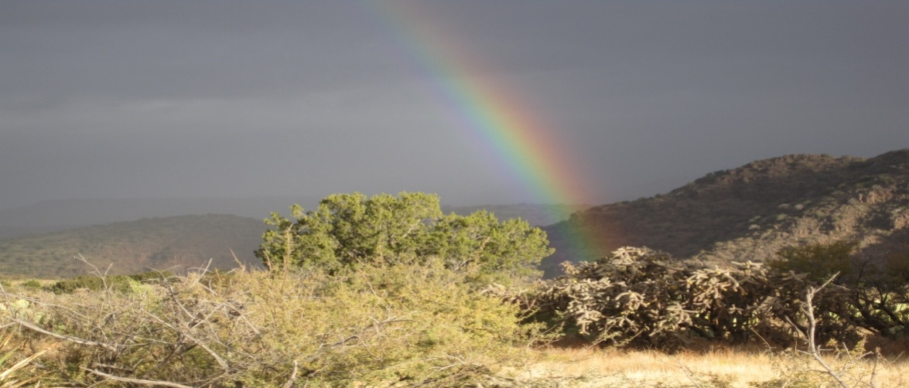

It was January 2010, and the San Carlos Apache Tribe was about to conduct their highly sought big game tag sales. Long time friends and hunting companions James White and myself, (Kevin Wheeler) decided to pursue the highly coveted Coues deer permits. Those familiar with the process know full well that the rut tags for the San Carlos Reservation are extremely limited and the most difficult to obtain. After some discussion, we decided to try our chances on purchasing a non rut tag which would schedule us to hunt in late November, prior to the rut. I contacted, good friend and highly respected guide, Julius Hostetler of HOSS GUIDE SERVICE, as he had spent years as a wildland fire-fighter and had grown up hunting these units on the reservation. He assured us that there was good quality Coues deer in the area we had in mind, and that with a little patience, dedicated glass time, and persistence covering ground that we would have good opportunities.
Fast forward to March 2010, we were celebrating our good fortune in finally obtaining the 2 tags for our targeted hunt unit and began making plans. To say we were “stoked” would be an understatement, as we have hunted the state public land units for years and never could seem to find the 100+ in trophy class Coues deer we desired.
By October 2010 we were once again on our annual Arizona public land hunt pursuing the Grey Ghosts. We saw many immature deer and finally 2 “shooters” to be exact, but with limited days and blown stalks due to swirling winds, our time faded away unsuccessfully. However this year was different as we viewed it as just a mental and physical warm-up for the November hunt on the San Carlos.
In the days leading up to opening day, Julius had been pre-scouting and indicated he had seen good numbers of deer and some would definitely push the 100in mark. To any experienced Coues deer hunter, just hearing about bucks of that caliber gets the blood flowing! However, we reminded ourselves this was still Coues deer hunting and we knew we would be working hard for any chance to connect on nice bucks.

Opening day arrived and unfortunately due to work schedules we had to burn our first day traveling and setting up our campsite. In the meantime, Julius was out with Jeff Campbell who was sharing our camp and hunting the same unit. Amazingly I received a text that morning that they were currently on a stalk after spotting a nice deer that Julius judged was pushing the 100in. mark. Apparently, they had caught the deer bedded at over 600 yards. The next challenge was determining if they should pursue it or not considering it was opening day. Jeff concluded this was easy as he knew this was a big buck and opportunities can quickly pass.

After a good power hike and looking over the bedded buck with 2 other smaller 90in class bucks, Jeff setup and took his 300 yard shot, clearly hitting the buck in its bed. The buck stood up and Jeff fired another well placed round to put the buck down for good. As they approached the buck, jaws dropped in awe as the buck appeared bigger than they originally estimated. The 4x4 field scored 105 and 5/8. Jeff having come from New Mexico to hunt the fabled San Carlos could not have been happier. Julius and he had become friends while fighting wild-land fires throughout the years, and this was a great conclusion to a common goal of getting Jeff a trophy class Coues.

After the hunt they met us back in camp. We were stunned and the excitement grew. Jeff told us the story and that Julius’ new nickname would be “Ol’ Eye Balls” because he had spotted the buck with his naked eye at over 600 yards.

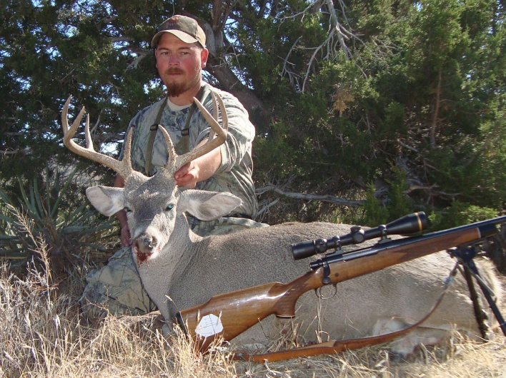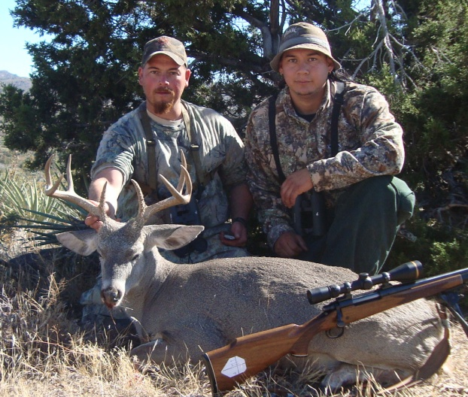
Jeff Campbell and his 105 5/8 San Carlos Coues
Knowing that a nice buck had been killed within hours of the first day kind of gives one the assumption that this was going to be easy, but by experience Jimmy and I knew it’s never quite like that. As the next several days wore on, we spent hours glassing, and finding lots of does and immature bucks at all hours of the daylight. The country is big, beautiful, and exactly where you would expect to find a nice Coues deer buck but some days you are just not going to see them. For the next 2 days we didn’t find a single mature buck. On the afternoon of the 3rd day, Julius recommended an area that held a nice bowled shape canyon which offered plenty of glassing areas with a drainage providing water and said we wouldn’t be disappointed.
Late afternoon, I glassed up 3 bucks feeding mid-slope about ½ mile away from us. At that distance it was hard to see if they were in the size class worth pursuing. Light was beginning to fade, so I kept an eye on the deer while Julius broke away and hiked a ridge just west of us. On top of the ridge, just before final light he jumped 3 bucks and one was a definite 100 inch class buck. We made plans to let things settle down and return the next morning to see if we could find the bucks and put together a stalk. Once again I found the same 3 bucks at first light and they were progressing up a steep slope high on a ridge east of us. After putting the spotting scope on them, we decided to pursue the bigger buck which was definitely in our desired size range. Jimmy and I started off on a steep climb and used an approach angle to avoid detection from the wind. After about 4 ½ hours of a careful and painstaking stalk, we discovered that the deer had not bedded where we thought and had slipped out of the area undetected long before we got there. We decided to hunt the remaining daylight out high on the same ridge and come down the south face of the mountain where Julius could pick us up on the other side. This turned out to be a minor miscalculation and after no luck encountering any bucks, we dodged boulders and endless fields of prickly pear and cholla cactus coming in several hours after dark.

The evenings were always spent discussing our various options, what we had found, and discussing hunt plans for the next day. On the fifth day Julius had to leave camp to check in with his office, but convinced us to try an area we had not hunted yet. He had hunters in the past take nice bucks out of that area and felt the odds were always good there.
We headed out early and drove to the location using a map Julius had marked out. As we approached the rim and started glassing, I spotted a nice buck moving up and climbing up out of the rim. After watching this buck disappear into heavy brush at a long distance, we decided to pass and move on. Making our way to an elevated location overlooking the bowl and spending the next 2 hours intensely glassing, I spotted 2 bucks coming out of the scrub oaks. These deer appeared to be looking for a place to bed and one of them was looking like a definite shooter. I put the spotting scope on him at 1200 yards and could tell he was very tall with good length in his main-beams, G2, and G3 tines. Jimmy stayed behind while I mapped out a stalk to give me a closer look at this buck and make a determination. I used a side ravine 3 ridges parallel to close the distance on the buck but things looked a little different once I got into the area and I wasn’t exactly sure where I had pin pointed the bedding location. By trying to keep my scent from drifting toward the deer, I had gotten a little higher elevation than planned. As I approached the area I thought the deer were bedded, I realized they had moved, most likely heading up the rim around and behind me to get my wind. I moved several hundred yards behind and to the left where I caught the big deer sneaking away. A quick moving shot at roughly 100 yards through an open lane in the brushy area and I nailed him with my 300 short mag. This big typical 4x4 buck had great main beams and only an inch from touching in the front. Not only a great unique buck, but a buck scoring 109 and 7/8. Wow!
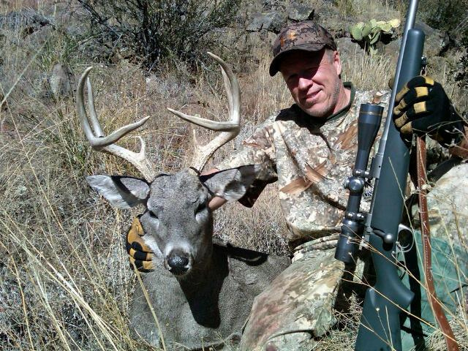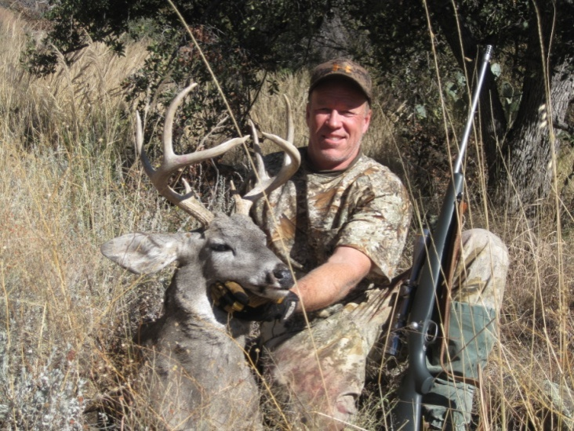
Kevin Wheeler’s 109-7/8” San Carlos Coues
After that day, we continued with a focus on finding Jimmy a big buck. We teased a lot and joked that he would probably end up getting a toad, that there is always a reason for pressure on the last hunter to fill his tag. The next morning after we had spotted 4 bucks that were 90in class bucks and with a day and a half left and the hunt winding down, a buck of that caliber was looking good. This time I stayed behind while Jimmy and Julius closed the distance to try and setup for a shot. As the bucks sensed their presence and moved into cover up the ridge, Jimmy had a hard time locating the bigger buck in the heard. After losing sight of the deer in the heavy brush, we circled around the mountain and posted on a rocky knob that Julius knew was there. Amazingly we glassed the bucks up again in a near-by side canyon walking away from us about 400 yards. Julius quickly alerted Jimmy of the location and they set up for a shot. The biggest buck with unusually white antlers was trailing in the rear, but Jimmy was given little time to shoot. The deer was now over 450 yards, and Jimmy tried a long shot. The shot hit just low and the white horned buck ran off with no hesitation of leaving the county. Surprisingly the other buck froze and we realized that he was nearly as big, his horn color had blended perfectly with the surroundings, resulting in us underestimating his initial size. Jimmy was able to get in one more shot at nearly 600 yards distance and this proved to be the closest shot before the deer headed over the ridge. He had never tried a shot at this distance, and we were amazed at how close he came. A hint of disappointment filled the air as we all realized we had one more full day of hunting….opportunities had come and gone. We continued to hunt and glass that day but never found a buck worthy of shooting. After the day was over, we all discussed plans for the last day. It’s amazing how well these friendly debates at the end of each day always resulted in a great plan for tomorrow.
The morning of the last day we went to where we had hunted the previous day hoping to spot the same bucks or even find a different bachelor heard. We decided to place Jimmy sitting on a water hole with Julius and myself splitting up and glassing from different ridges. I spotted a nice 3x3 buck in the 85 class and after some discussion Jimmy decided he wanted something a little bigger and decided to be patient. Around 3pm, Julius signaled me from a remote ridge and I was unsure of what he had from his location. He was signaling us to get a move on towards him.
After retrieving Jimmy from his blind on the water hole, we hiked towards Julius’ location on the remote ridge. After reaching him with about 30 minutes of daylight we found he had glassed up a buck bedded at the base of a large oak over-looking a nearby drainage. Julius had pin-pointed the exact location and mapped out a stalk on this buck with perfection. The wind was blowing hard in our face, but provided also cover. With about 20 minutes of daylight left, Julius stayed high on the ridge to continue watching the buck as Jimmy and I began the approach for a shot. We were coming down an open and exposed ridge with little cover so we slowly worked down for a position to shoot without alarming the buck. I ranged the deer at 430 yards while the sun was starting to go down and time was running out. We had lost sight of the location, but as we approached an angle to where we could get a visual location on the buck, we realized he was still bedded. Now at about 300 yards with the wind blowing right to left across us, we maneuvered to close under 300 yards and get a more open shooting lane. Jimmy setup his tripod to shoot off of at 283 yards and settled in. With the final light fading on his last day, Jimmy squeezed off his shot. The big buck stood up and was trying to figure where the shot was coming from. Another shot was launched and the buck was hit low on the shoulder. In the confusion, the buck actually ran toward our shooting location and presented a closer shot, now about 250 yards. Jimmy let loose another well placed round, we heard the unmistakable thud, and watched the deer go down. As we approached the deer, some serious whooping and back slapping let loose as we shouted to Julius that Jimmy had smoked a really good deer with significant mass. He came off that ridge quickly and after seeing the buck up close yelled ” I take my previous score back.” He initially judged it at a high 90s buck, but with all the extra points and mass, we both guessed this deer would score close to the one I harvested. This 5x7 buck ended up scoring 109 and 6/8. We were all excited and took many pictures, prepared the deer, and started the long pack out to the road. We got back to camp late that night, but spent our evening celebrating our awesome hunting experiences.
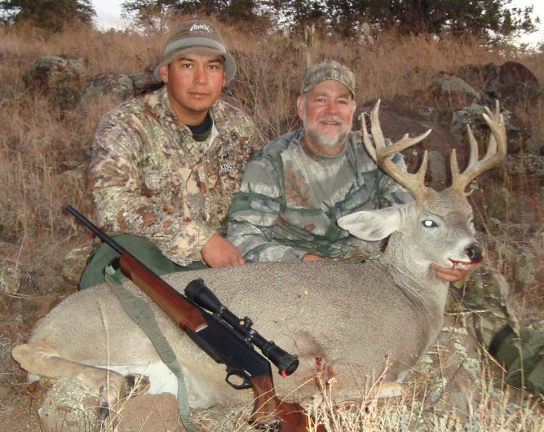
James White’s (Jimmy) 109- 6/8 San Carlos Coues with Guide Julius Hostetler
It was an impressive hunt and final result with all 3 hunters able to connect on 3 bucks over 105 inches in one week!! The hard work, perseverance, and patience paid off. Our thanks to good friend and excellent guide, Julius Hostetler from HOSS GUIDE SERVICE, for not only his expertise, but for the great camaraderie and good times. Julius truly loves to hunt and “get after it”. Also our compliments and thanks to the San Carlos Apache Tribe for their successful management strategies and reduced hunt pressure resulting in truly quality trophy big game.
